# CS 255 Business Requirements Document Template

Complete this template by replacing the bracketed text with the relevant information.

This template lays out all the different sections that you need to complete for Project One. Each section has guiding questions to prompt your thinking. These questions are meant to guide your initial responses to each area. You are encouraged to go beyond these questions using what you have learned in your readings. You will need to continually reference the interview transcript as you work to make sure that you are addressing your client’s needs. There is no required length for the final document. Instead, the goal is to complete each section based on your client’s needs.

**Tip:** You should respond in a bulleted list for each section. This will make your thoughts easier to reference when you move into the design phase for Project Two. One starter bullet has been provided for you in each section, but you will need to add more.

## System Components and Design

### Purpose

*What is the purpose of this project? Who is the client and what do they want their system to be able to do?*

* The purpose of this project is to create a system for the client DriverPass. They want their system to offer online classes and practice tests, as well as the ability to create and cancel appointments with in-person training.
* Client hopes to offer better training for future drivers so they are more prepared for their driving tests and capable of passing

### System Background

*What does DriverPass want the system to do? What is the problem they want to fix? What are the different components needed for this system?*

* Need for better driver training
* System will offer online classes and practice tests
* System will offer the ability to reserve and cancel in-person lessons
* System will offer three different packages available to the customer

### Objectives and Goals

*What should this system be able to do when it is completed? What measurable tasks need to be included in the system design to achieve this?*

* Ability to access data from anywhere, online or offline, with the capability of downloading reports
* Different security clearances for employees, with the head of IT being able to access all employee accounts
* Tracking changes made to reservations, and the ability to find and print a full activity report for reservations, including who made the reservation, who cancelled it, and who modified it last.
* The ability for customers to make reservations for in-person training, including the day and time they want their lesson. Can be done online or by communicating with the secretary over the phone or in office.
* Tracking what driver, car, and time the customer is matched up with
* Ability for client to disable a package if no longer available
* Registration for a new customer should include: Full name, address, phone number, state, and credit card information, as well as pickup and drop-off location (which should be the same)
* User should be able to reset password if forgotten
* System should notify the client of any changes or updates from DMV
* System needs to run off the internet, preferably over the cloud
* User interface should show tests taken, in progress, and completed, as well as test name, time taken, score, and status (not taken, in progress, failed, passed)
* Driver should be able to leave comments for user, including time of lesson
* User (or secretary) should be able to fill out student information
* Include a site page where contact info for client and user is available

## Requirements

### Nonfunctional Requirements

*In this section, you will detail the different nonfunctional requirements for the DriverPass system. You will need to think about the different things that the system needs to function properly.*

#### Performance Requirements

*What environments (web-based, application, etc.) does this system need to run in? How fast should the system run? How often should the system be updated?*

* The system needs to run in a web-based environment.
* Each web-page should have a loading time of no more than 3 seconds.
* Minor updates to the system should occur whenever the DMV has a change in their rules, policies, or sample question.
* Major system updates should happen once every two years.

#### Platform Constraints

*What platforms (Windows, Unix, etc.) should the system run on? Does the back end require any tools, such as a database, to support this application?*

* The system should run on any platform, as it is a web-based system.
* The back end requires a database of all users and a database of all appointments including the customer, the trainer, and car included in each appointment.

#### Accuracy and Precision

*How will you distinguish between different users?* *Is the input case-sensitive? When should the system inform the admin of a problem?*

* Each user can log in with their individual email, which is not case sensitive.
* Each user has a personal password, which is case sensitive, connected to their email
* Each user is classified either as user, trainer, or admin.
* The admin should only be informed of a problem is the user’s password is entered incorrectly 5 times without being reset.

#### Adaptability

*Can you make changes to the user (add/remove/modify) without changing code? How will the system adapt to platform updates? What type of access does the IT admin need?*

* Changes should be able to be made to the user without changing code.
* The system should only be unavailable for less than a day during system updates, while the update is being implemented.
* The IT admin needs to be able to access all employee and customer data, as well as have all-access to the entire system in order to make updates and see what needs updated.

#### Security

*What is required for the user to log in? How can you secure the connection or the data exchange between the client and the server? What should happen to the account if there is a “brute force” hacking attempt? What happens if the user forgets their password?*

* A user needs their email and case-sensitive password to login to their account.
* Each user should have a secure connection to the server by the client accepting cookies when using the system, which ends when the user closes their browser.
* Should a brute force hacking attempt happen, the user account will be locked down and the user contacted to change their login password.
* If a user forgets their password, they can have a reset password link sent to the email connected to their account.

### Functional Requirements

*Using the information from the scenario, think about the different functions the system needs to provide. Each of your bullets should start with “The system shall . . .” For example, one functional requirement might be, “The system shall validate user credentials when logging in.”*

* The system shall validate user credentials when logging in.
* The system shall allow admins to access data from anywhere with the ability to download reports.
* The system shall allow for three different classes of users, each with separate classes of security.
* The system shall allow customer users to make reservations for in-person training, including the day and time of the reservation.
* The system shall keep a database of the driver, car, and time for each reservation made.
* The system shall notify the admin of any changes or updates made to the DMV rules, policies, and sample questions.
* The system shall run off the internet, over the cloud.

### User Interface

*What are the needs of the interface? Who are the different users for this interface? What will each user need to be able to do through the interface? How will the user interact with the interface (mobile, browser, etc.)?*

* The user will interact with the interface over a web browser.
* Trainer users will be able to track what appointments they have, which customer they will be training, and which car they will be driving. They will also be able to leave notes for the customer they are training.
* Admin users will be able to view a list of customers, appointments, and trainers, as well as all customer information.
* Customer user will be able to view their information, a photo of the driver they will be training with, notes left by the trainer, tests and test progress, and a photo and any special needs the customer has.
* Customers will be able to schedule appointments over the internet.
* The interface should be easy to navigate, with all pages easily accessible from a menu and the home screen accessible by clicking the company logo at the top of each webpage.

### Assumptions

*What things were not specifically addressed in your design above? What assumptions are you making in your design about the users or the technology they have?*

* Driver notes by the trainer should include lesson time, start and end hour, and the comments left.
* Tests taken by the customer should show which have been taken, which tests are in progress or completed, and test status (not taken, in progress, failed, or passed).
* Customers will be able to access a page containing contact information for the company.
* Admins and trainers will be able to view contact information for customers.
* The assumption is that the customer will have regular access to internet and a device with a web browser.

### Limitations

*Any system you build will naturally have limitations. What limitations do you see in your system design? What limitations do you have as far as resources, time, budget, or technology?*

* The schedule for the system is strict, lasting 5 months, beginning January 22nd and ending May 10th.
* The client has a specific idea for the layout of the main webpage, but no limitations for the setup of each other webpage.
* The admin will not be able to add or delete modules without the head of IT.

### Gantt Chart

*Please include a screenshot of the GANTT chart that you created with Lucidchart. Be sure to check that it meets the plan described by the characters in the interview.*

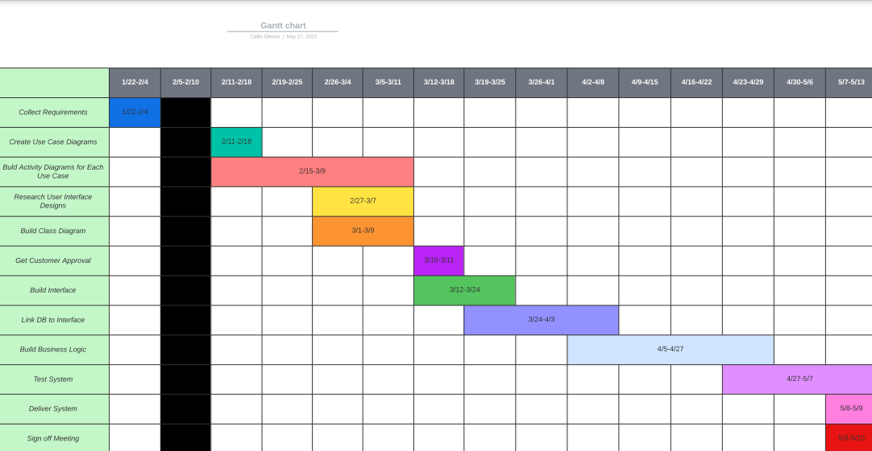

**Sources**

Dissanayaka, A. (2022, August 3). *Client-Server interaction of a web application in terms of secured access.* Medium. https://medium.com/@ayshsandu/client-server-interaction-of-a-web-application-in-terms-of-secured-access-3bd0971d072e

*How fast should a website load in 2023?* (n.d.). BrowserStack. Retrieved June 4, 2023, from <https://www.browserstack.com/guide/how-fast-should-a-website-load#:~:text=The%20short%20answer%20to%20the>

‌Forrest, K. J. (n.d.). *How Often Should You Update Your Website?* Www.smartbugmedia.com. https://www.smartbugmedia.com/blog/update-website#:~:text=The%20most%20simple%20answer%20to

‌